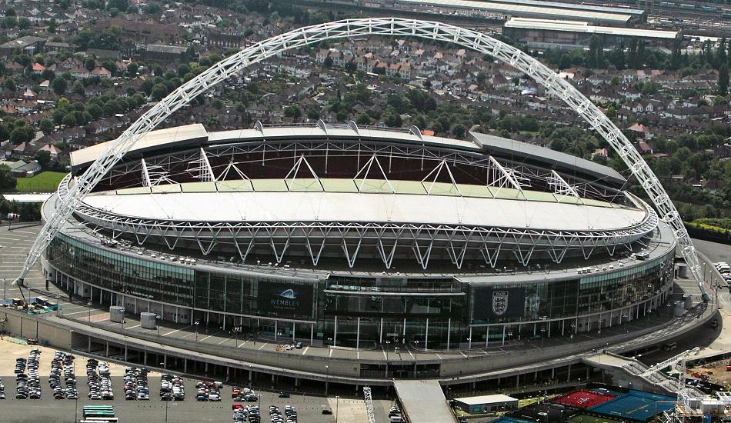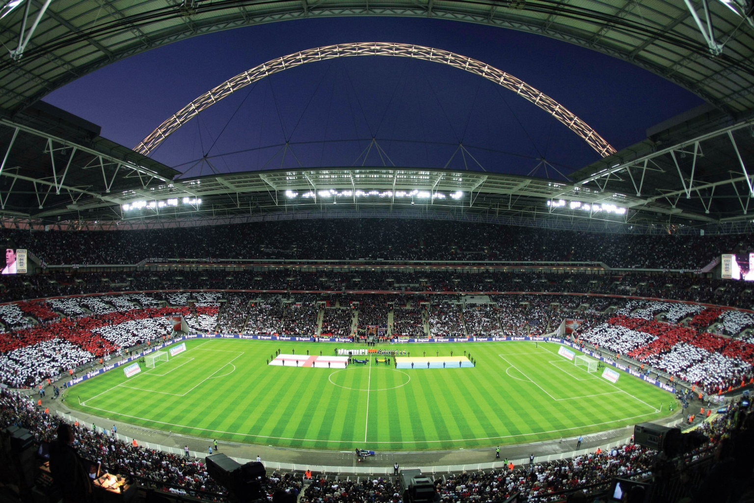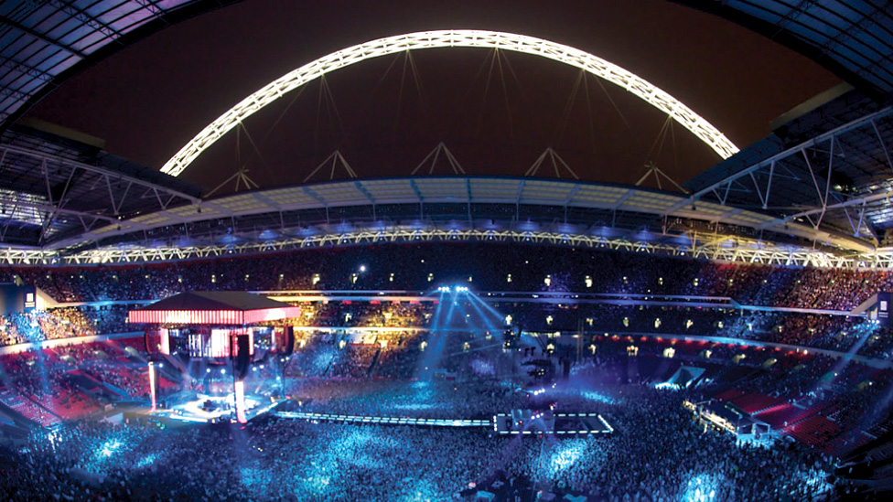

Look at the pictures of the Stadium.

Think about what Jamie and his friends would see in front of them

Now write a description of what the Stadium must have looked like to Jamie when he first saw it. Write in the first person and remember to include what you are FEELING.