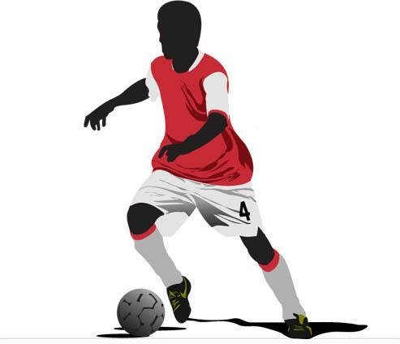
After reading the first two chapters, what sort of person do you think Jamie Johnson is? Record your ideas around the figure below and remember to include some evidence from the text!

